

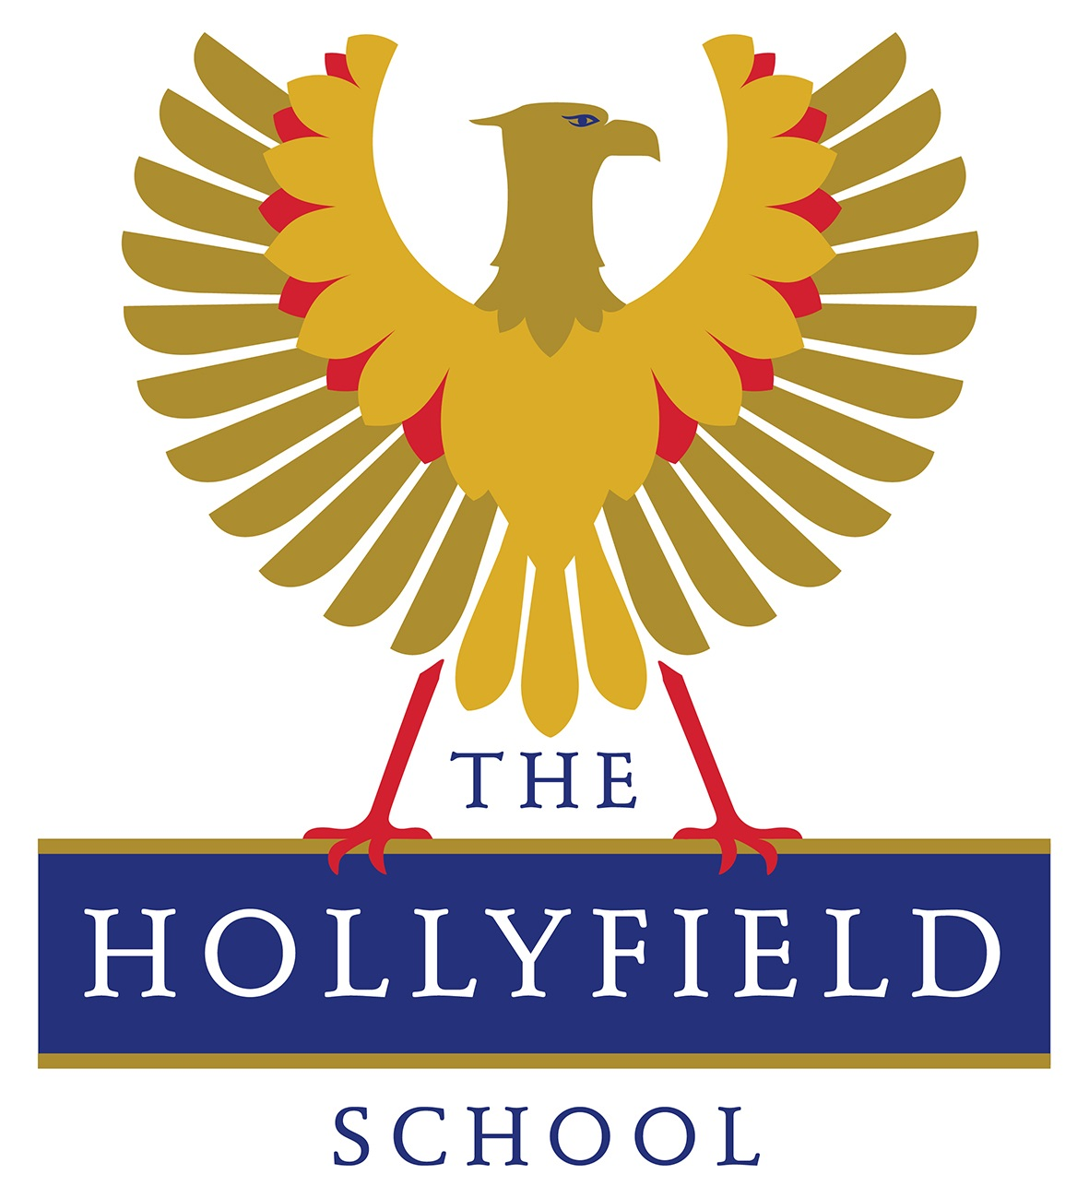

THE HOLLYFIELD SCHOOL
Surbiton Hill Road Surbiton
Surrey
KT6 4TU
Tel: 020 8339 4500
11-18 mixed (N.O.R. - 1081)
email: vacancies@hollyfield.kingston.sch.uk

Senior Administrative and Admissions Officer
Part-time, permanent position
Hours: 32 hours per week, term time only (39 weeks per year)
Working pattern:
- Monday, Tuesday, Thursday and Friday: 8:00 am to 3:30 pm
(includes a 30-minute unpaid lunch break)
- Wednesday: 8:00 am until 12:00 pm.
Salary: NJC pay spine points 20 to 24
- Full time equivalent: £37,790 to £40,016 per annum
- Actual Pro-Rata Salary: £28,856 to £30,556 per annum
Start Date: December 2026

The Role
We are seeking a Senior Administrative and Admissions Officer to provide a high level of administrative support to assist in the smooth and effective operation of the school.

The ideal candidate is a multitasker with exceptional knowledge and experience to keep our office operations running like clockwork.

Key Responsibilities
- Lead and line-manage the Administration Office team in conjunction with the Headteacher’s PA.
- Oversee the smooth running of the admissions process in conjunction with AfC school admissions.
- To provide specific administrative support to all staff and prioritise workload.
- Manage administrative systems and the school’s parent email contact system.
- To oversee the organisation of and provide administrative support for school events and attend Open Evening every year.
- To provide admin support for the preparation of the annual staff/school and parent calendar.
- Undertake such other duties as may be required commensurate with grade and purpose of job.

What We Are Looking For
• Experience: High level of administrative experience.
• IT Skills: Proficient in Microsoft Office (Word, Excel, Outlook) and Google Drive.
• Communication Skills: Exceptional verbal and written communication skills with a professional demeanour.
• Organisational Skills: Strong ability to prioritise tasks, multitask efficiently, and problem-solve.
• Reliability: High level of punctuality, discretion, and attention to detail. To adhere to the school dress code (professional business dress) and other school procedures.

Essential
Excellent knowledge of MS Office and Google Drive

Desirable
Previous school experience
Knowledge of school admissions process
Knowledge of Arbor/Parentmail
Educated to GCSE level or equivalent

Training will be provided for the most suitable candidate.

About The Hollyfield School
Based in the beautiful Surbiton area of Surrey, we benefit from excellent transport links to central London, enabling our staff and students to access a wealth of cultural and professional opportunities. We are proud to be part of the Every Child, Every Day Multi Academy Trust.

“Pupils achieve very well in their examinations. This is because the school delivers an ambitious and balanced curriculum, underpinned by the highest expectations for all pupils. This includes the popular and successful sixth form.“ Ofsted 2025.

How to Apply
- Job applications can be made through the TES website. Please note we cannot accept CVs and our standard application form must be completed.
- We would encourage early applications as we reserve the right to appoint before the closing date, should a suitable candidate be found
- Only shortlisted candidates will be called for an interview.

Closing Date for receipt of applications is: 10am on Tuesday 3 November 2026

For further details about the school, please visit our website: www.hollyfield.kingston.sch.uk

Safeguarding and Compliance
The Governing and Trust Bodies are committed to safeguarding and promoting the welfare of all our children and expect staff to share this commitment. We fully recognise our responsibilities for safeguarding and child protection. Any offer of employment will be subject to pre-employment checks, including an enhanced Disclosure and Barring Service (DBS) check, overseas criminal record checks where relevant, a background check including an online check of the applicant’s social media accounts, and receipt of satisfactory references. It is an offence to apply to work with children if you are barred from engaging in regulated activity relevant to children. The schools within the Trust are committed to all aspects of personal development, are inclusive, and seek to ensure every student achieves to the best of their ability.

